Vaibhav Gupta (vgupta1@presidio.com)

After checking the project files, I found that exception handling is used only in three places in this Bus Booking System project. This project looks like it was developed with AI support, because code is clean and follows common patterns. From what I understood, the project is handling exceptions in a basic but useful way.

1. Database Layer (PostgresSqlRunner.cs)
In backend, exception handling is used while working with database transactions.
- Opens database connection.
- Starts transaction.
- Runs the database operation.
If operation is successful:
- Transaction is committed using CommitAsync().
If any error happens:
- catch block executes.
- Transaction is rolled back using RollbackAsync().
- After that exception is thrown again using throw.
This is good because if database operation fails, wrong or half data will not be saved.

backend/Data/PostgresSqlRunner.cs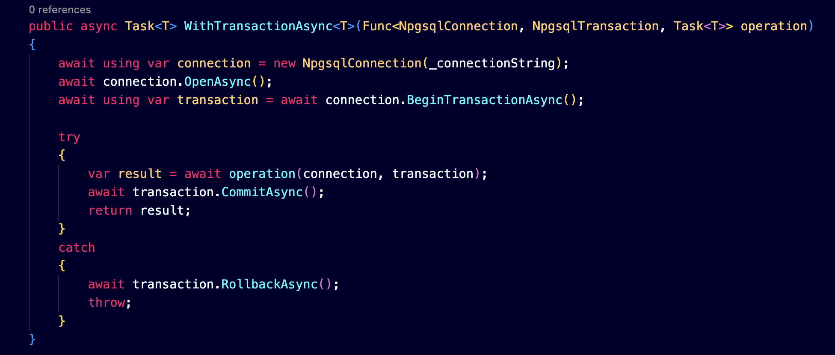

2. Authentication Service (auth.service.ts)
In frontend auth service, exception handling is used while decoding JWT token.
- Reads token.
- Splits token data.
- Decodes payload.
If token is valid:
- User email, role, and userId are returned.
If token is invalid or damaged:
- catch block handles error.
- Instead of crashing application, it returns null values.
This helps application continue running even if token has problem.
frontend/src/app/core/services/auth.service.ts
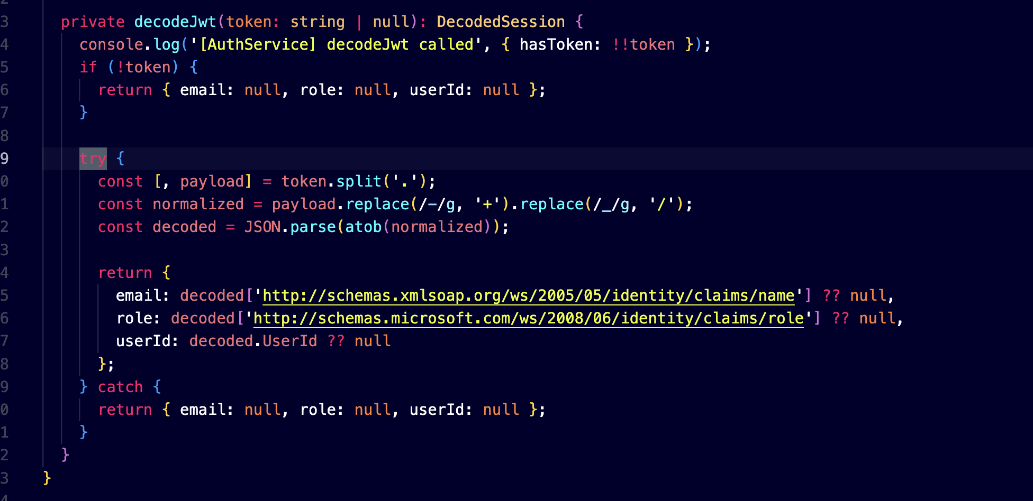

3. API Service (api.service.ts)
In frontend API service, exception handling is used while reading data from local storage.
- Gets saved trip data from local storage.
- Converts JSON string into object.
If data is correct:
- Trip data is returned.
If parsing fails or data is corrupted:
- catch block runs.
- It returns null.
This prevents application from breaking because of invalid local storage data.

frontend/src/app/core/services/api.service.ts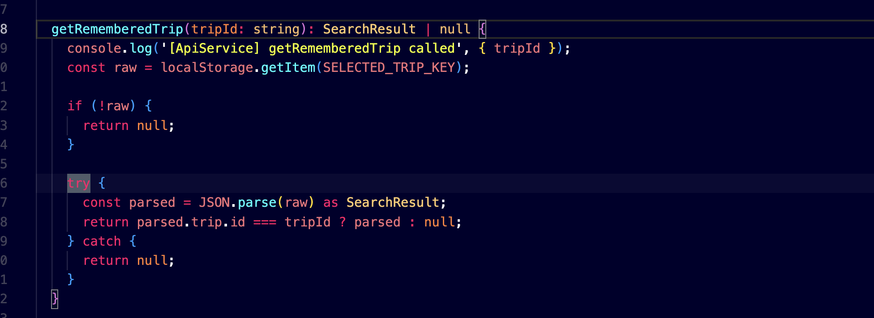

My Understanding
Overall, exception handling in this project is simple. AI-generated code seems to focus on:
- Preventing application crash.
- Returning safe values when error happens.
- Protecting database consistency using rollback.
But one thing I noticed is logging of errors is not properly done in catch blocks.
So, exception handling is present, but only in important areas like database transaction, authentication, and local storage handling.
There are still several places where exception handling can be improved, such as:
Validation of city entered during trip search.
Passenger name validation.
Age and traveler details validation.
Payment request validation.
Seat selection and booking conflict handling.

